Ex. No 3 Hadoop Commands

Hadoop Commands Hadoop Commands - 33 Frequently used HDFS shell commands
# Open a terminal window to the current working directory. The deafult directory is /user/hduser
1. Print the Hadoop version
hadoop version
2. List the contents of the root directory in HDFS
#
hdfs dfs –ls /
3. Report the amount of space used and available on currently mounted file system
#
hdfs dfs -df hdfs:/
4. Count the number of directories, files and bytes under the paths that match the specified file pattern ( count the dir, file and bytes in specfied dir)
#
hdfs dfs -count hdfs:/
5. Run a DFS file system checking utility checks all the files are health
#
hdfs fsck / -files
6. Run a cluster balancing utility
#
hdfs balancer
7. Create a new directory named “hadoop” below the /user/hduser directory in HDFS. Since you’re # currently logged in with the “hduser” user ID /user/hduser is your home directory in HDFS.
#
make all the directories -
hdfs dfs -mkdir /user
hdfs dfs -mkdir /user/hduser
hdfs dfs -mkdir /user/hduser/hadoop
8. Add a sample text file from the local directory named “data” to the new directory you created in HDFS during the previous step.
#
hdfs dfs -put /data/sample.txt /user/hduser/hadoop
9. List the contents of this new directory in HDFS.
#
hdfs dfs -ls /user/hduser/hadoop
10. Add the entire local directory called “retail” to the /user/hduser directory in HDFS.
#
hdfs dfs -put /data/retail /user/hduser/hadoop
11. Since /user/hduser is your home directory in HDFS, any command that does not have an absolute path is interpreted as relative to that directory. The next command will therefore list your home directory, and should show the itmems you’ve just added there.
#
hdfs dfs –ls
12. See how much space this directory occupies in HDFS.
#
hdfs dfs -du -s -h /user
13. Delete a file ‘customers’ from the “retail” directory.
#
hdfs dfs -rm hadoop/retail/customers - these are with relative path
or
hdfs dfs -rm /user/hduser/hadoop/retail/customers - This is absolute path
14. check this file is no longer in HDFS.
#
hdfs dfs -ls hadoop/retail/customers
15. Delete all files from the “retail” directory using a wildcard.
#
hdfs dfs -rm hadoop/retail/*
16. To empty the trash
#
hdfs dfs -expunge
17. Finally, remove the entire retail directory and all of its contents in HDFS.
#
hdfs dfs -rm -r hadoop/retail
# 18. List the hadoop directory again
#
hdfs dfs -ls hadoop
19. Add the purchases.txt file from the local directory
# named “/home/hduser/” to the hadoop directory you created in HDFS
#
hdfs dfs -copyFromLocal /home/sam/purchases.txt hadoop/ relative path
20. To view the contents of your text file purchases.txt which is present in your hadoop directory.
#
hdfs dfs -cat hadoop/purchases.txt
21. Add the purchases.txt file from “hadoop” directory which is present in HDFS directory to the directory “data” which is present in your local directory
#
hdfs dfs-copyToLocal hadoop/purchases.txt /home/sam/data ( this is your local disk)
22. cp is used to copy files between directories present in HDFS
#
hdfs dfs -cp /user/hduser/*.txt /user/hduser/hadoop
23. ‘-get’ command can be used alternaively to ‘-copyToLocal’ command
#
hdfs dfs -get hadoop/sample.txt /home/sam/Desktop
24. Display last kilobyte of the file “purchases.txt” to stdout.
#
hdfs dfs -tail hadoop/purchases.txt
25. Default file permissions are 666 in HDFS, Use ‘-chmod’ command to change permissions of a file
#
hdfs dfs -chmod 600 hadoop/purchases.txt
26. Move a directory from one location to other
#
hdfs dfs -mv hadoop apache_hadoop
27. Default replication factor to a file is 3.
# Use ‘-setrep’ command to change replication factor of a file
#
hdfs fs -setrep -w 2 apache_hadoop/sample.txt
28. List all the hadoop file system shell commands
#
hdfs dfs
Try this:
- create a folder as CSE
- add a file with your rollno to hdfs in CSE folder
- Give the permission fo file as 644
- find the size of the folder
- display the contents of the file using command
Ex. No 4 Map Reduce Programming

Apache Hadoop : Creating Wordcount Java Project with Eclipse
Step 1: Create a JavaProject named as “WordCount”
File > New > Project > Java Project > Next.
"WordCount" as our project name and click "Finish"
Step 2: Creating class files
Right click on source, New > Class:
Class Name as - WordCount and click finish.
Use package name as p1
Step 3 : Getting references to hadoop libraries
We'll get bunch of refereces which refer to Hadoop libraries.
Right click on WordCount project and select "Properties":
Hit "Add External JARs...", then, File System > usr > lib > hadoop :
- /usr/local/hadoop/share/common
- /usr/local/hadoop/share/mapreduce

Step 4: Copy the Code
package p1;
import java.io.IOException;
import java.util.*;
import org.apache.hadoop.fs.Path;
import org.apache.hadoop.conf.*;
import org.apache.hadoop.io.*;
import org.apache.hadoop.mapreduce.*;
import org.apache.hadoop.mapreduce.lib.input.FileInputFormat;
import org.apache.hadoop.mapreduce.lib.input.TextInputFormat;
import org.apache.hadoop.mapreduce.lib.output.FileOutputFormat;
import org.apache.hadoop.mapreduce.lib.output.TextOutputFormat;

public class WordCount {

public static class Map extends Mapper<LongWritable, Text, Text, IntWritable> {
private final static IntWritable one = new IntWritable(1);
private Text word = new Text();

public void map(LongWritable key, Text value, Context context) throws IOException, InterruptedException {
String line = value.toString();
StringTokenizer tokenizer = new StringTokenizer(line);
while (tokenizer.hasMoreTokens()) {
word.set(tokenizer.nextToken());
context.write(word, one);
}
}
}

public static class Reduce extends Reducer<Text, IntWritable, Text, IntWritable> {

public void reduce(Text key, Iterable<IntWritable> values, Context context)
throws IOException, InterruptedException {
int sum = 0;
for (IntWritable val : values) {
sum += val.get();
}
context.write(key, new IntWritable(sum));
}
}

public static void main(String[] args) throws Exception {
Configuration conf = new Configuration();

Job job = new Job(conf, "wordcount");

job.setOutputKeyClass(Text.class);
job.setOutputValueClass(IntWritable.class);

job.setMapperClass(Map.class);
job.setReducerClass(Reduce.class);

job.setInputFormatClass(TextInputFormat.class);
job.setOutputFormatClass(TextOutputFormat.class);

FileInputFormat.addInputPath(job, new Path(args[0]));
FileOutputFormat.setOutputPath(job, new Path(args[1]));

job.waitForCompletion(true);
}

}

Step 5: Exporting the Jar

Now we want to export it as a jar.
Right click on WordCount project and select "Export...":

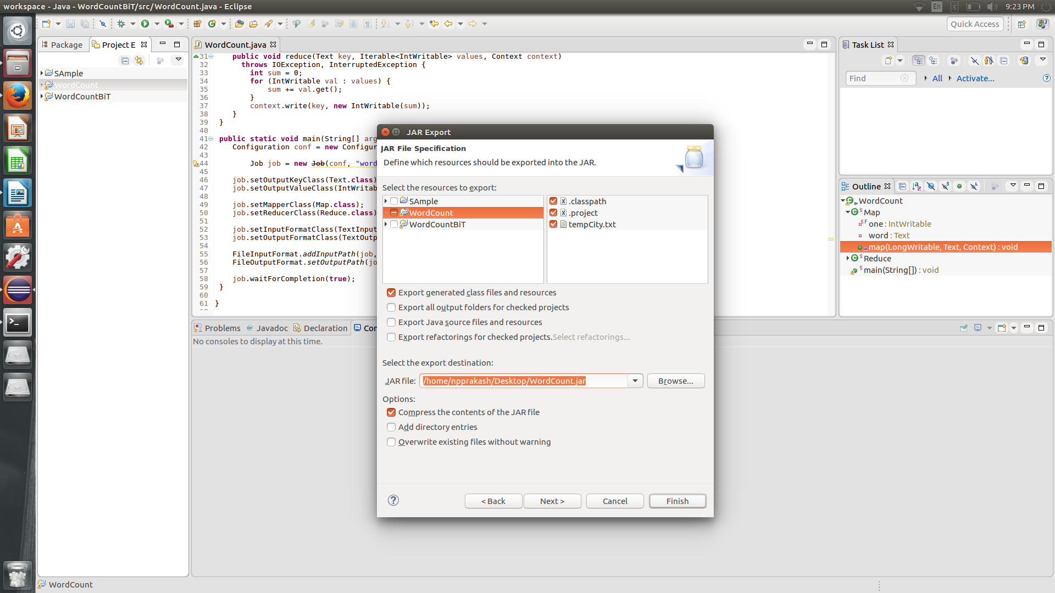

specify the main classs as p1.WordCount
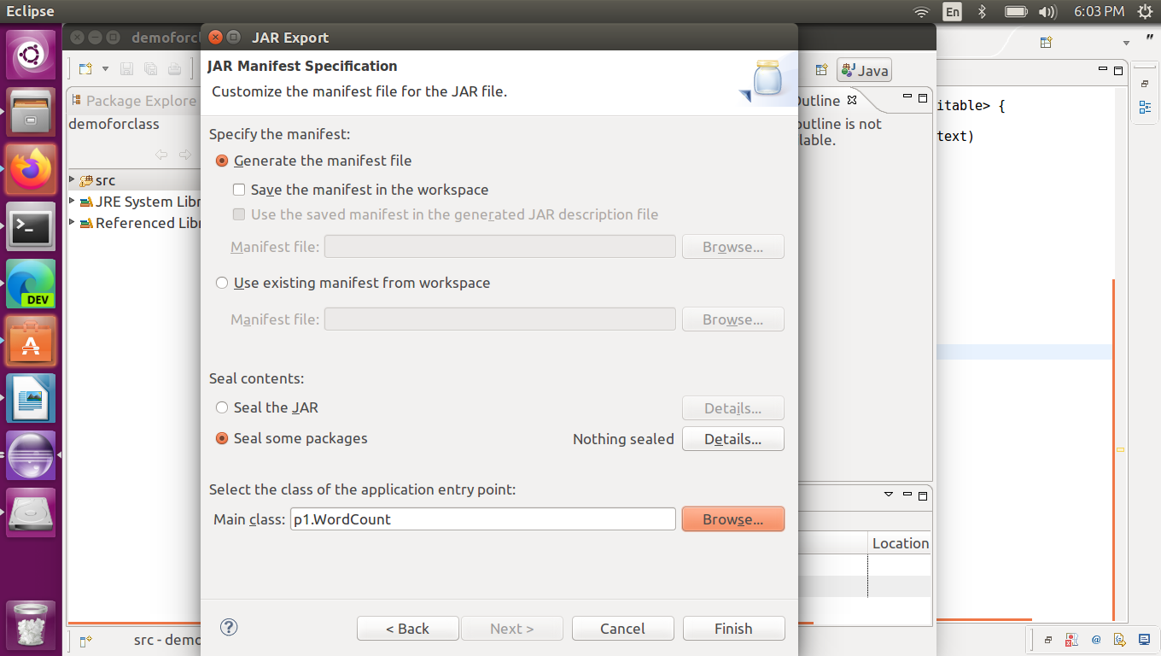
Step 6: Create a text file named as wordcount.txt
hduser@npprakashhp:~$ cat /home/npprakash/wordcount.txt
Step 7: Move the local file into HDFS.
Create folder user in hdfs – hdfs dfs -mkdir /user
copy the file wordcount.txt to /user in hdfs
hduser@npprakashhp:~$ hdfs dfs -put /home/npprakash/Desktop/wordcount.txt /user
Step 8: Run the jar file.
hduser@npprakashhp:~$ hdfs jar /home/npprakash/Desktop/WordCount.jar /usr/local/hadoop/input/wordcount.txt output
Step 9: List the files into the HDFS ouput directory.
hduser@npprakashhp:~$ hadoop fs -ls output/
Step 10 : Check the results
hduser@npprakashhp:~$ hadoop fs -cat output1/part-r-00000
To execute with package name:
hadoop jar /home/karthi/Desktop/WordCount_example.jar p1.WordCount /input/wc.txt output
where p1 is the package name and WordCount is the class name

Sample input file : wc.txt
this is a sample text
this is cat dog

